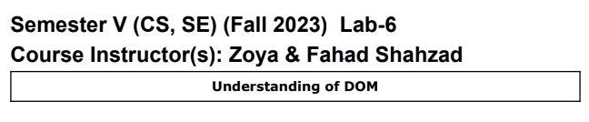

# **Name: Faizan Ahmed**

# **CMS ID: 053-18-0016**

# **BSCS-V-SEC-B**

# 

**CODE:**

<!DOCTYPE html>

<html>

<head>

<meta charset=utf-8 />

<title>JS Bin</title>

</head>

<body>

<input type="button" value="Click to set paragraph background color"

onclick="set_background()">

<p>w3resource JavaScript Exercises</p>

<p>w3resource PHP Exercises</p>

    <script>

    function set_background() {

        const randomColor = "#" + Math.floor(Math.random()*16777215).toString(16);

        document.body.style.backgroundColor = randomColor;

    }

    const changeColorButton = document.getElementById("changeColorButton");

    changeColorButton.addEventListener("click", set_background);

</script>

</body>

</html>



**CODE:**

<!DOCTYPE html>

<html>

<head>

<meta charset=utf-8 />

</head>

<body>

<p><a id="w3r" type="text/html" hreflang="en-us" rel="nofollow" target="_self"

href="http://www.w3resource.com/">w3resource</a></p>

<button id="getValue" onclick="getAttributes()">Click here to get attributes value</button>

<script>

    document.getElementById("getValue").addEventListener("click", function() {

        const link = document.querySelector("a");

        const hrefValue = link.getAttribute("href");

        const hreflangValue = link.getAttribute("hreflang");

        const relValue = link.getAttribute("rel");

        const targetValue = link.getAttribute("target");

        const typeValue = link.getAttribute("type");

alert(`href: ${hrefValue}\nhreflang: ${hreflangValue}\nrel: ${relValue}\ntarget: ${targetValue}\ntype: ${typeValue}`);

    });

</script>

</body>

</html>

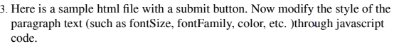

**CODE:**

<!DOCTYPE html>

<html>

<head>

<meta charset=utf-8 />

<title>JS DOM paragraph style</title>

</head>

<body>

<p id='text'>JavaScript Exercises - w3resource</p> <div>

<button id="jsstyle" onclick="js_style()">Style</button> </div>

<script>

    document.getElementById("jsstyle").addEventListener("click", function() {

        const paragraph = document.getElementById("text");

        paragraph.style.fontSize = "24px";

        paragraph.style.fontFamily = "Arial, sans-serif";

        paragraph.style.color = "blue";

    });

</script>

</body>

</html>

4. Write a JavaScript function to add rows to a table.

**CODE:**

<!DOCTYPE html>

<html>

<head><br>

<meta charset=utf-8 />

<title>Insert row in a table - w3resource</title> </head>

<body>

<table id="sampleTable" border="1">

<tr>

    <td>Row1 cell1</td>

    <td>Row1 cell2</td>

</tr>

<tr>

    <td>Row2 cell1</td>

    <td>Row2 cell2</td>

</tr>

</table>

<br>

<input type="button" id="addrow" onclick="insert_Row()" value="Insert row"> </body>

<script>

    document.getElementById("addrow").addEventListener("click", function() {

        const table = document.getElementById("sampleTable");

        const newRow = table.insertRow();

        const cell1 = newRow.insertCell(0);

        const cell2 = newRow.insertCell(1);

        cell1.innerHTML = "Row3 Cell1";

        cell2.innerHTML = "Row3 Cell2";

    });

</script>

</html>

**5.Given the following HTML:**

<!DOCTYPE html>

<html lang="en">

<head>

<meta charset="UTF-8">

<title>Document</title>

</head>

<body>

<div class="header">

</div>

<section id="container">

<ul>

<li class="first">one</li>

<li class="second">two</li>

<li class="third">three</li>

</ul>

<ol>

<li class="first">one</li>

<li class="second">two</li>

<li class="third">three</li>

</ol>

</section>

<div class="footer">

</div>

</body>

**Write the code necessary to do the following:**

**1. Select the section with an id of container without using querySelector.**

    document.getElementById("container");

**2. Select the section with an id of container using querySelector.**

document.querySelector("#container");

**3. Select all of the list items with a class of "second".**

    document.querySelectorAll(".second");

**4. Select a list item with a class of third, but only the list item inside of the ol tag.**

    document.querySelector("ol .third");

**5. Give the section with an id of container the text "Hello!".**

    var give = document.querySelector("#container");

    give.innerHTML="Hello";

**6. Add the class main to the div with a class of footer.**

    const footerElement = document.querySelector(".footer");

    footerElement.classList.add("main");

**7. Remove the class main on the div with a class of footer.**

    const footerRemover = document.querySelector(".footer");

    footerRemover.classList.remove("main");

**8. Create a new li element.**

const newLI = document.createElement("li");

**9. Give the li the text "four".**

    newLI.textContent = "four";

**10.Append the li to the ul element.**

    const myul = document.getElementById("myUL");

    myul.appendChild(newLI);

**11.Loop over all of the lis inside the ol tag and give them a background color of "green".**

const myol = document.getElementById("myOl");

    const list_item = myol.getElementsByTagName("li");

    for (let i = 0; i < list_item.length; i++) {

        list_item[i].style.backgroundColor = "green";

    }

**12.Remove the div with a class of footer.**

    // footerRemover already decleared in above Q.7

    // const footerRemover = document.querySelector(".footer");

    if (footerRemover) {

        footerRemover.parentNode.removeChild(footerRemover);

    }

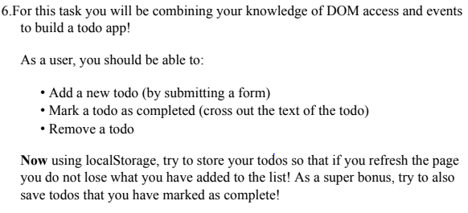

**CODE:**

<!DOCTYPE html>

<html lang="en">

<head>

    <meta charset="UTF-8">

    <meta name="viewport" content="width=device-width, initial-scale=1.0">

    <title>Todo App</title>

    <style>

        body {

            font-family: Arial, sans-serif;

        }

        .completed {

            text-decoration: line-through;

        }

    </style>

</head>

<body>

    <h1>Todo App</h1>

    <form id="todoForm">

        <input type="text" id="todoInput" placeholder="Add a new todo" required>

        <button type="submit">Add</button>

    </form>

    <ul id="todoList"></ul>

    <script>

        const todoForm = document.getElementById("todoForm");

        const todoInput = document.getElementById("todoInput");

        const todoList = document.getElementById("todoList");

        // Load todos from localStorage

        const savedTodos = JSON.parse(localStorage.getItem("todos")) || [];

        function saveTodos() {

            localStorage.setItem("todos", JSON.stringify(savedTodos));

        }

        function renderTodos() {

            todoList.innerHTML = "";

            savedTodos.forEach((todo, index) => {

                const li = document.createElement("li");

                const checkbox = document.createElement("input");

                checkbox.type = "checkbox";

                checkbox.checked = todo.completed;

                const text = document.createElement("span");

                text.textContent = todo.text;

                if (todo.completed) {

                    text.classList.add("completed");

                }

                const deleteButton = document.createElement("button");

                deleteButton.textContent = "Delete";

                checkbox.addEventListener("change", () => {

                    todo.completed = checkbox.checked;

                    if (todo.completed) {

                        text.classList.add("completed");

                    } else {

                        text.classList.remove("completed");

                    }

                    saveTodos();

                });

                deleteButton.addEventListener("click", () => {

                    savedTodos.splice(index, 1);

                    saveTodos();

                    renderTodos();

                });

                li.appendChild(checkbox);

                li.appendChild(text);

                li.appendChild(deleteButton);

                todoList.appendChild(li);

            });

        }

        renderTodos();

        todoForm.addEventListener("submit", (e) => {

            e.preventDefault();

            const newTodoText = todoInput.value.trim();

            if (newTodoText !== "") {

                savedTodos.push({ text: newTodoText, completed: false });

                saveTodos();

                renderTodos();

                todoInput.value = "";

            }

        });

    </script>

</body>

</html>

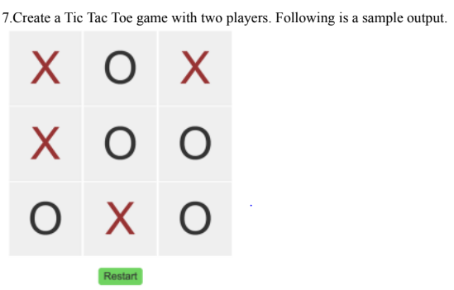

**CODE:**

<!DOCTYPE html>

<html lang="en">

<head>

    <meta charset="UTF-8">

    <meta name="viewport" content="width=device-width, initial-scale=1.0">

    <title>Tic Tac Toe</title>

    <link rel="stylesheet" href="https://maxcdn.bootstrapcdn.com/bootstrap/4.5.2/css/bootstrap.min.css">

    <style>

        .cell {

            width: 100px;

            height: 100px;

            text-align: center;

            padding-top: 20dp;

            font-size: 36px;

            cursor: pointer;

            border: 1px solid #000;

        }

    </style>

</head>

<body>

    <div class="container mt-5" style="background-color: rgb(233, 139, 17);">

        <h1 class="text-center mb-3">Tic Tac Toe</h1>

        <div class="row justify-content-center">

            <div class="col-4">

                <div class="alert alert-info text-center" id="message">Player X's Turn</div>

                <div class="alert alert-danger text-center d-none" id="winner">Player X wins!</div>

                <div class="alert alert-warning text-center d-none" id="draw">It's a draw!</div>

                <div class="row">

                    <div class="col cell" onclick="makeMove(0)"></div>

                    <div class="col cell" onclick="makeMove(1)"></div>

                    <div class="col cell" onclick="makeMove(2)"></div>

                </div>

                <div class="row">

                    <div class="col cell" onclick="makeMove(3)"></div>

                    <div class="col cell" onclick="makeMove(4)"></div>

                    <div class="col cell" onclick="makeMove(5)"></div>

                </div>

                <div class="row">

                    <div class="col cell" onclick="makeMove(6)"></div>

                    <div class="col cell" onclick="makeMove(7)"></div>

                    <div class="col cell" onclick="makeMove(8)"></div>

                </div>

                <center><button class="btn btn-primary mt-3" onclick="resetBoard()" style="margin-bottom: 20px;">Restart</button></center>

            </div>

        </div>

    </div>

    <script>

        let board = ["", "", "", "", "", "", "", "", ""];

        let currentPlayer = "X";

        let gameOver = false;

        function makeMove(cellIndex) {

            if (!gameOver && board[cellIndex] === "") {

                board[cellIndex] = currentPlayer;

                document.getElementsByClassName("cell")[cellIndex].innerText = currentPlayer;

                currentPlayer = currentPlayer === "X" ? "O" : "X";

                if (checkWin()) {

                    document.getElementById("message").style.display = "none";

                    document.getElementById("winner").style.display = "block";

                    gameOver = true;

                } else if (checkDraw()) {

                    document.getElementById("message").style.display = "none";

                    document.getElementById("draw").style.display = "block";

                    gameOver = true;

                } else {

                    document.getElementById("message").innerText = `Player ${currentPlayer}'s Turn`;

                }

            }

        }

        function checkWin() {

            const winConditions = [

                [0, 1, 2],

                [3, 4, 5],

                [6, 7, 8],

                [0, 3, 6],

                [1, 4, 7],

                [2, 5, 8],

                [0, 4, 8],

                [2, 4, 6]

            ];

            for (const condition of winConditions) {

                const [a, b, c] = condition;

                if (board[a] && board[a] === board[b] && board[a] === board[c]) {

                    return true;

                }

            }

            return false;

        }

        function checkDraw() {

            return board.every(cell => cell !== "");

        }

        function resetBoard() {

            board = ["", "", "", "", "", "", "", "", ""];

            currentPlayer = "X";

            gameOver = false;

            document.getElementById("message").style.display = "block";

            document.getElementById("message").innerText = "Player X's Turn";

            document.getElementById("winner").style.display = "none";

            document.getElementById("draw").style.display = "none";

            const cells = document.getElementsByClassName("cell");

            for (const cell of cells) {

                cell.innerText = "";

            }

        }

    </script>

</body>

</html>